Experiment 2.4
Determination and plotting of Electric field (E) and Electric flux density (D) in a sphere full of charges with varying radius

Code File Name: Exp2_4_ElectricField_InsideOutsideSphere.m
Code
clc;
rho0 = 3e-6;
epsilon = 8.854e-12;
R = 2;
r = linspace(0.1, 4, 100);
E = zeros(size(r));
for i = 1:length(r)
if r(i) < R
E(i) = rho0 * r(i) / (3 * epsilon);
else
Q = rho0 * (4/3) * pi * R^3;
k = 1/(4*pi*epsilon);
E(i) = k * Q / (r(i)^2);
end
end
plot(r,E,'LineWidth',2);
xlabel("Radius (m)");
ylabel("Electric Field (E)");
title("Electric Field Inside and Outside Sphere");
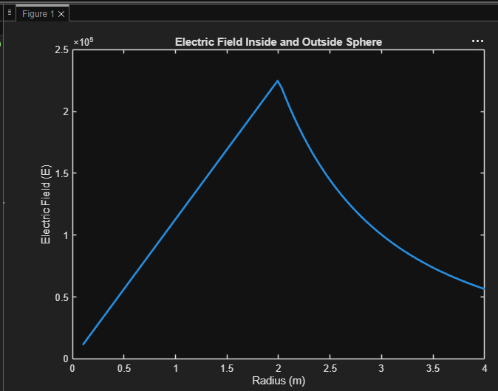
Output Graph

